Air Suspension Control Function, and Warning Messages CGEA1.3

Functional Description

Air Suspension Control Function is used by the operator to disable or enable the rear air suspension system. This feature is initially implemented on 2016 V363C and then 2016.5 V363E. The warning messages are used to convey to the operator that the air suspension is on due to speed or faulty. Verify through PDL if a program is equipped with air suspension and if so verify with feature owner as to whether this STSS is required.

IPC transmits AirSusp_D_RqDrv signal to VDM to indicate whether the operator has requested through the settings screen to change the state of the air suspension (on to off or off to on).

The VDM remembers the state of the air suspension feature over each key cycle and controls the initial battery connect default state. IPC checks or unchecks the Air Suspension status as per the state of AirSusp_D_Stat signal which is transmitted by VDM. IPC displays air suspension on due to vehicle speed or air suspension fault as per the state of the AirSuspMsgTxt_D_Rq signal.

This STSS also supports CGEA1.1/1.2.

Interfaces

Interface Context Diagram (I/O Block Diagram)

Air Suspension Control Function Context Diagram

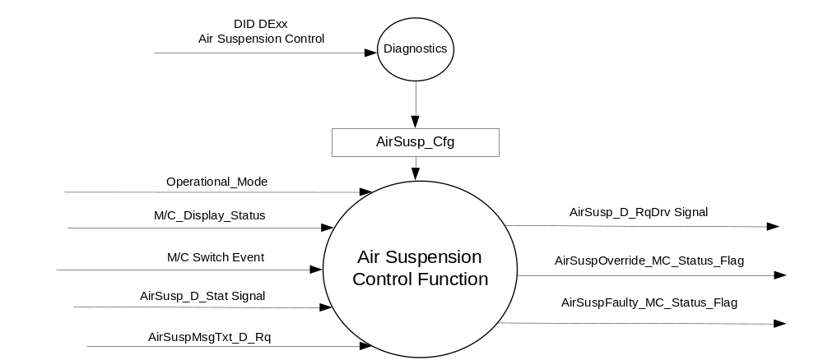

Inputs
- INTERNAL:
- Operational_Mode
- AirSusp_Cfg
- M/C Switch Event
- M/C_Display_Status

- MUX message on the CAN Bus from the VDM.

- AirSusp_D_Stat Signal
Signal Name | Size  (bits) | Detail | Units | Res. | Offset | State  Encoded | Min | Max
AirSusp_D_Stat | 2 |  | SED | 1 | 0 |  | 0 (0x0) | 3 (0x3)
 |  | Null |  |  |  | 0x0
 |  | Off |  |  |  | 0x1
 |  | On |  |  |  | 0x2
 |  | Not Used |  |  |  | 0x3

- AirSuspMsgTxt_D_Rq Signal
Signal Name | Size  (bits) | Detail | Units | Res. | Offset | State  Encoded | Min | Max
AirSuspMsgTxt_D_Rq | 2 |  | SED | 1 | 0 |  | 0 (0x0) | 3 (0x3)
 |  | No Message |  |  |  | 0x0
 |  | Override |  |  |  | 0x1
 |  | Faulty |  |  |  | 0x2
 |  | Not Used |  |  |  | 0x3

Outputs
- AirSuspOverride_MC_Status_Flag
- AirSuspFaulty_MC_Status_Flag
- Mux message on the CAN Bus to VDM

- AirSusp_D_RqDrv Signal
Signal Name | Size  (bits) | Detail | Units | Res. | Offset | State  Encoded | Min | Max
AirSusp_D_RqDrv | 2 |  | SED | 1 | 0 |  | 0 (0x0) | 3 (0x3)
 |  | No_Mode_Selected |  |  |  | 0x0
 |  | Off |  |  |  | 0x1
 |  | On |  |  |  | 0x2
 |  | Not Used |  |  |  | 0x3

Function/Performance

Operational Modes

Mode | Differentiating Vehicle Conditions
Sleep Mode | Air Suspension Control Function / Text Messages Disabled
Limited Mode | Air Suspension Control Function / Text Messages Disabled
Normal Mode | Air Suspension Control Function / Text Messages Enabled / Disabled
Crank Mode | Air Suspension Control Function / Text Messages Enabled / Disabled

Voltage Levels

Refer to the Cluster Feature table located in the Operational Modes and Voltage Range section in this SPSS.

Human-Machine Interface

Visual

Indicator Graphics / Display Format

Indicator Color Coordinates

Reference section COLOR & ILLUMINATION REQUIREMENTS (GRAPHICS).

Indicator Characteristics

Refer to Message Center X Display_Y Button Interface Section, where X and Y are appropriate values in this document.

Audio

None.

Switch Control Logic

Consumer access to the Air Suspension Control shall be as specified in the message center basic functionality display as specified in Message Center X Display_Y Button Interface Section, where X and Y are appropriate values in this document.

System Accuracy

Within a 100msec of receiving a message that results in a change of state the cluster will update the display to the proper status.

Operation: Performance and Functional

Subsystem Algorithm Flowcharts / State Diagrams

Figure 1: Air Suspension Control DID DExx Function
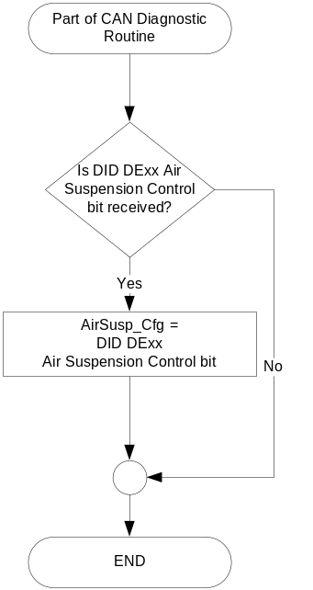
Figure 2: IPC Operator Setup Function

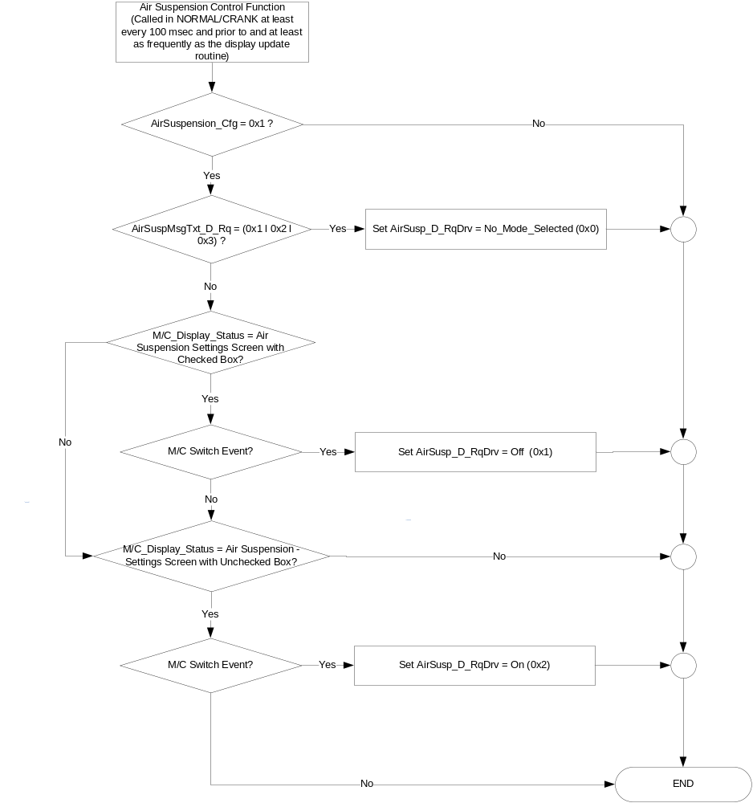

- Message Center Setup Display
Operational  _Mode | AirSusp_Cfg | AirSusp_D_Stat | Air Suspension Settings Screen
Normal or Crank | Enabled | Null (0x0) l  Not Used (0x3) l Missing | Unchecked Box
Normal or Crank | Enabled | Off (0x1) | Unchecked Box
Normal or Crank | Enabled | On (0x2) | Checked Box
Normal or Crank | Disabled | X | Not Present
Note: Air Suspension Settings Screen Unchecked Box means the Air Suspension System is OFF or its state is unknown. Air Suspension Settings Screen Checked Box means the Air Suspension System is ON. Alternate
graphics could be employed such as “radio buttons” or other could be employed.

- State Matrix for Air Suspension Warnings
Operational_Mode | AirSuspMsgTxt_D_Rq  Signal | AirSuspOverride_MC_Status_Flag | AirSuspFaulty_MC_Status_Flag
Normal or Crank | Override (0x1) | Active | Inactive
Normal or Crank | Faulty (0x2) | Inactive | Active
Normal or Crank | Missing as per 1.4.1 | Inactive | Active
All Other Cases |  | Inactive

- MC_Status_Flag to Warning Message ID
AirSuspOverride_MC_Status_Flag | AirSuspFaulty_MC_Status_Flag | MC Warning  Message ID | Warning  Type | Associated  Warning Chime
Active | Inactive | W3361 | TA | Info
Inactive | Active | W3360 | SC* | Info

Operation Description (supports algorithm flowchart /state diagram)
- The Air Suspension Settings Screen always follows the current state of the input signal AirSusp_D_Stat.
- If AirSusp_Cfg = Disabled then this function is not active and Air Suspension Settings Screen is not present in the Setup Menu.
- Use Case 1: In this use case air suspension is ON and VDM is reacting to an IPC command to turn air suspension OFF when the vehicle is at a speed where VDM will not allow air suspension to be turned OFF. Air Suspension is ON and Air Suspension Off is selected through the HMI, then IPC sends Set AirSusp_D_RqDrv = Off (0x1). If Vss > Threshold, then in response to IPC sending AirSusp_D_RqDrv = Off (0x1), VDM module will send AirSuspMsgTxt_D_Rq = 0x1 and IPC shall display W3361 and set AirSusp_D_RqDrv to No_Mode_Selected (0x0). Threshold is a parameter stored in the VDM and is the maximum speed VDM will allow air suspension to be turned off. IPC truth table and flow chart support this strategy.
- Use Case 2: In this use case air suspension is OFF as commanded previously by IPC and IPC is reacting to VDM turning air suspension ON due to the vehicle speed becoming too high.
If Air Suspension has been selected OFF and and Vss transitions > Threshold then VDM shall send AirSuspMsgTxt_D_Rq = Override (0x1) and IPC shall display W3361 and set AirSusp_D_RqDrv = No_Mode_Selected (0x0). IPC truth table and flow chart support this strategy.
- For Use Case 1 & 2, VDM shall send AirSuspMsgTxt_D_Rq = 0x1 for 3 consecutive transmissions and then send AirSuspMsgTxt_D_Rq = 0x0 until Use Case 1 or Use Case 2 occur again or VDM determines the system is Faulty. This assumes AirSuspMsgTxt_D_Rq signal message is 1000ms Event/Periodic.
- VDM shall send AirSuspMsgTxt_D_Rq = 0x2 continuously upon VDM determining there is a fault with the air suspension system.
- W3361 must be a TA warning type.

Function Safety Classification (EMC)

Class B.

Memory Storage
Parameter Name | Description | Value at  Battery Connect | Value at  Module Wake-up | Value at Transition from Limited Mode to Normal l Crank
AirSusp_Cfg | IPC configuration used to enable/disable Air Suspension Control Function | Used Stored Value | Used Stored Value | Use Stored Value
AirSusp_D_Stat | Input signal received by the IC, defining current status  of Air Suspension (On/Off) | Null (0x0) | Null (0x0) | Null (0x0)
AirSuspMsgTxt_D_Rq Signal | CAN Signal received from VDM | No Message (0x0) | No Message (0x0) | No Message (0x0)
AirSusp_D_RqDrv Signal | Output command signal sent  from the IC | No_Mode_Selected (0x0) | No_Mode_Selected (0x0) | No_Mode_Selected (0x0)
Operational_Mode | 4 state indicator for cluster  operational mode | Limited | Limited, Normal or Crank | Normal l Crank

Reconfigurable Telltale

Not Applicable.

Prove Out

Not Applicable.

Message Center Msg

Error Handling

Missing Message Strategy

The signals will be declared missing as per the Diagnostics section of this SPSS.

DTCs states and history will be determined as per the Diagnostics section of this SPSS.

Diagnostics

Self Test

None.

Engineering Test Mode

Reference section “Dealer / Engineering Test Mode (ETM)”.

Part II Performance

Supported Diagnostic Trouble Codes (DTCs)
DTC | Description
C12200 | Lost Communication with Vehicle Dynamics Control Module

DID DExx:
Block  Num | Block Description | Size (bits) | Type | Byte(s) | Bits | State: Description | "0" | "1" | Default | Comments/Information
PACKETED BLOCKS
$00 | Option Content (B&A) | 40 | 1 | * | * | Air Suspension Control | Disabled | Enabled | Enabled | Disabled means the function is not present in the vehicle
 | *Byte and bit location to be identified in Part II Specification for this cluster

Reference Specification

Revision History
SPSS Module Revision History

Revision Level | Name | Change Description | Date
1.0 | J.Blatchford | Initial Release | 3/24/14

